# Rubicon Global Azure Bootcamp 2018

# LAB 3: Step 2 - Connect to Microsoft Dynamics CRM

1. Open the bot solution from Lab 2 in Visual Studio
2. Go to Tools - NuGet Package Manager - Manage NuGet Packages for Solution...
3. Go to Browse and search for package Microsoft.IdentityModel.Clients.ActiveDirectory
4. Install the latest version of the package to the SimpleEchoBot project
5. Create a new folder Models under the SimpleEchoBot project and add the 4 classes from Lab3/Code/Models:  
     
   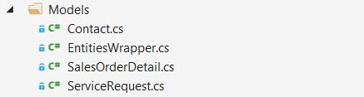
6. Create a new folder Dynamics under the SimpleEchoBot project and add the 4 classes from Lab3/Code/Dynamics:  
     
   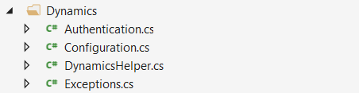
7. Log in to the Azure portal and navigate to your web bot's App Service.
8. Go to the Application settings blade under Settings
9. Scroll down to Application settings, and use Add new setting to add the following 4 settings. The values will be provided on site by Rubicon:  
     
   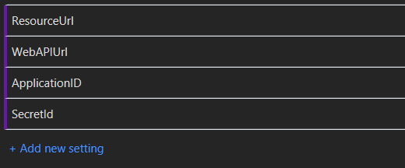

# LAB 3: Step 3 - Add dialogs that interact with CRM

## Identify Customer dialog

1. Add a new dialog to your bot to identify the customer.
2. Have the dialog ask for the users e-mail address.
3. Create a new CRM request uri string with the email address returned by LUIS  
     
   
4. Use the Dynamics helper to execute the request to the Dynamics CRM backend:  
     
     
     
   You may need to add a reference to Newtonsoft.Json and using Newtonsoft.Json.Linq  
     
   **HINT**: you can test you Identify Customer dialog using the following e-mail addresses:  
   john.doe@example.com, jane.doe@example.com and jan.jansen@example.com

## Identify Boiler dialog

1. Add another dialog that will query CRM orders for boilers sold to the customer
2. If multiple boilers are found, ask the user to select the correct boiler  
     
   **HINT**: John Doe has 0 boilers, Jane Doe has 1 boiler and Jan Jansen has 2 boilers

## Make Appointment dialog

1. Add yet another dialog that will ask the customer for a timeslot to make a service appointment.
2. After getting the available time, create a query to make an appointment within CRM.